This section will look at how ceramics has been used as a vehicle for analysing, discussing, critiquing and subverting particular social, political, and environmental issues. Ceramists vigilantly try to cast a new light to the realities of society which for many of us have become inured and offer a critique and commentary on them by their artworks.
Despite from the form of the artwork, all these projects had one thing in common: they used clay as the core of their practice to reveal their emotional reaction to the confronted unpleasant conditions, and their aim was to encourage discussion and debates to make us think about the raised issues.

Marian Heyerdahl, Offering from the Terracotta Woman Project, 2006

This project is a parade of 70 full-scale sculptures which look like traditional Xian terracotta warriors from back, but surprisingly have the look and body of women from the front. By reinterpreting the terracotta army of Xian in China, Heyerdahl focuses on women as the primary victims of war and reflects women's pain and difficulties in this male-dominated world. These women soldiers with their unhappy faces suffered from the issued being caused bythe war like loss of husband and children, being raped and getting pregnant, depict both fragility and strength of women at the same time.
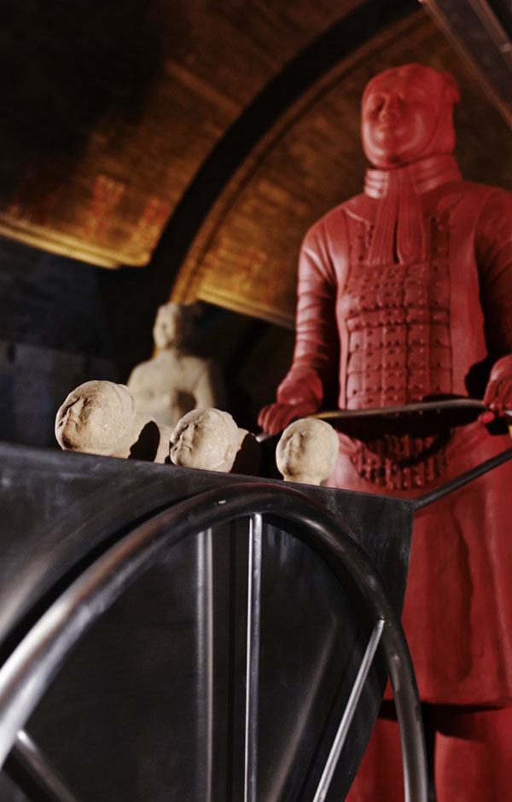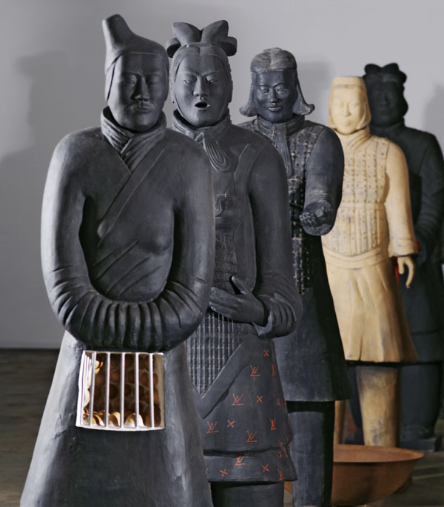

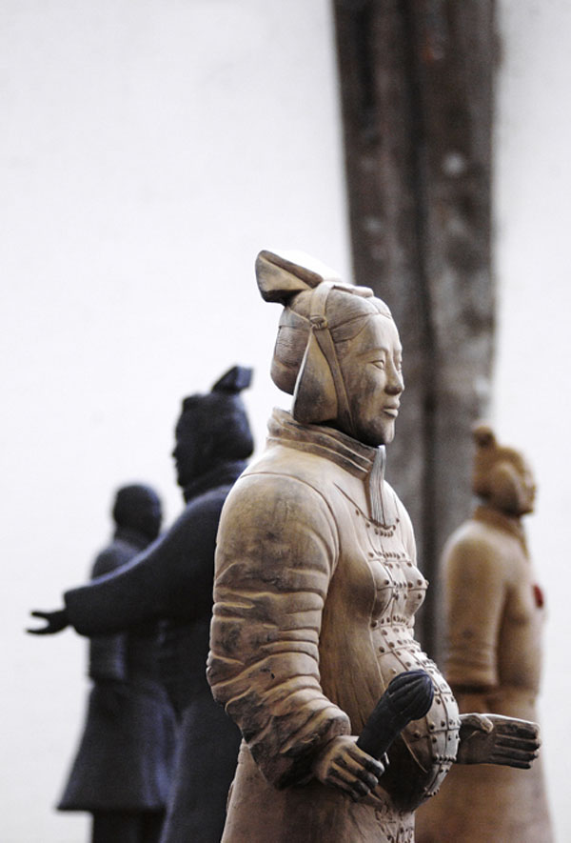

Damian O’Sullivan
I think there is something about the Netherlands that breeds good design. I came across the work of Damian O’Sullivan recently and I was completely in awe of his project on medical prosthetics which was nominated for the Danish Index Award in 2007.
O’Sullivan focused on how the use of artifical limbs, appendages and the like, are often ugly, mass produced objects that disempower the people who use them. O’Sullivan redesigned these ugly objects into carefully crafted, beautiful pieces of art by shifting the medium from plastic to porcelain. Porcelain is a material that evokes the fragility of a damaged or injured body but also has a sense of strength and dignity. This shift encourages a more empowered position for the people who use these beautiful prosthetics.
He used patterns from the blue and white Delft design that originated in the Netherlands in 16th century. Very beautiful and inspiring.
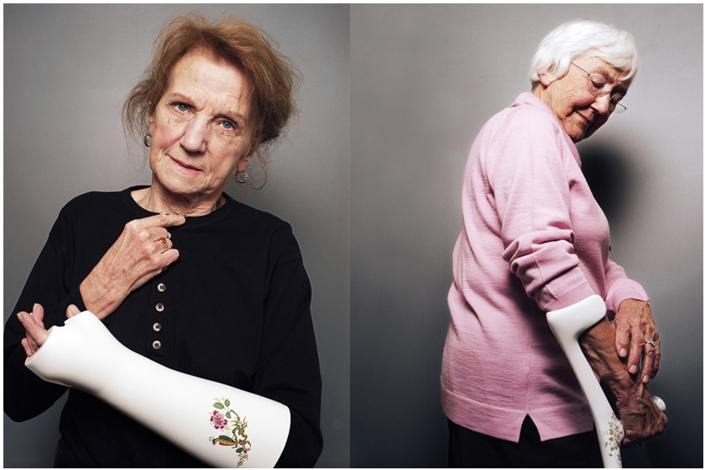
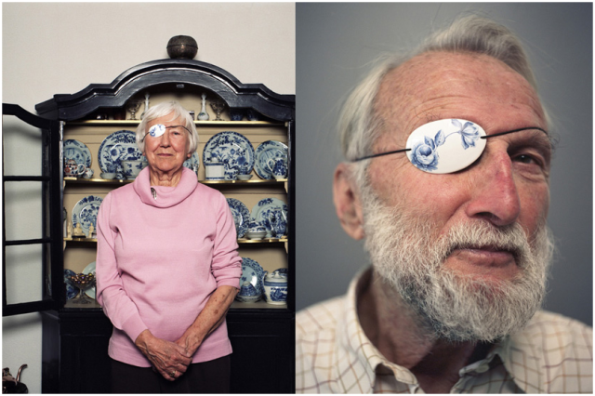

Kate MacDowell Masterfully Crafts Porcelain Sculptures Inspired by Nature
Through her porcelain sculptures, artist Kate MacDowell explores our romantic notions towards the environment alongside the human propensity for destruction. Her pieces are responses to the damage we inflict upon our habitats including climate change, genetic modification of organisms, and pollution. Human figures and animals act as symbols of the natural world, humorously and sometimes disturbingly transformed into new creatures that share qualities across the boundary of species. Hand crafted and exceptionally detailed, her work is a traditional medium that takes on contemporary significance in an age of ecological degradation.
Kate MacDowell and her ghostly sculptures are beautiful and somewhat haunting examinations of the human relationship with nature. Each piece is molded by hand and then hollowed. Choosing porcelain for its pallor, luminosity, and ability to show texture, it also allows her to represent “fragility of natural forms in a dying ecosystem, while paradoxically, being a material that can last for thousands of years and is historically associated with high status and value.”
Her compositions become frozen in time like preserved specimens, able to weather what their organic counterparts cannot. McDowell sees her work as a commentary on our actions against our environments, incorporating icons from mythology, art history, and figures of speech. Beautiful and thought-provoking, her representations remind us that we are a part of a complex web of life and have responsibilities as stewards.

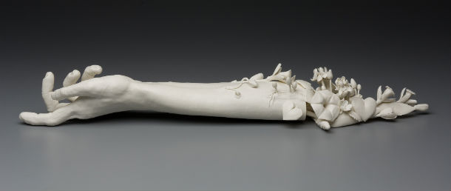
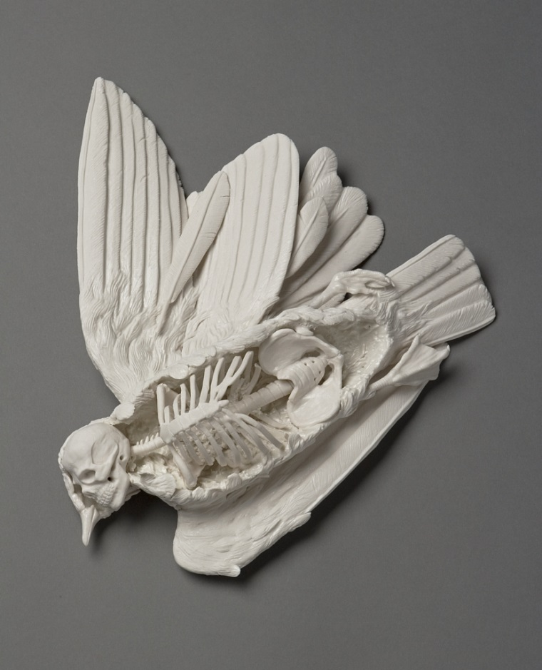

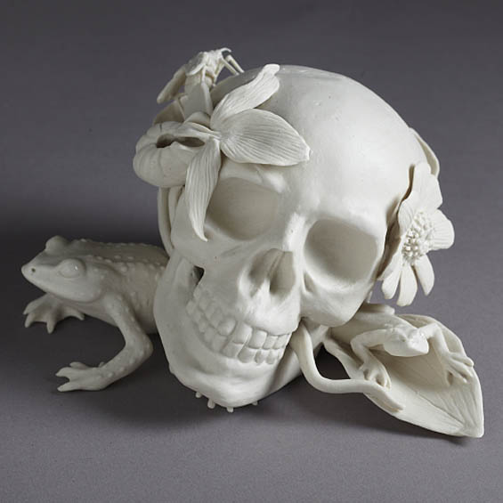

Carrie Reichardt, Zulu VooDoo Liberation Taxi, 2015
London-based artist, Carrie Reichardt uses ceramics, mosaic, murals techniques, screen-printing and graphic design in her work to generate complex, highly politicised works of art. By believing in that sometimes craft can be used to amplify the voices of others, Reichardt created Zulu VooDoo Liberation Taxi, a London black cab that she covered in a mosaic to raise awareness. By this project, Reichardt hoped to bring attention to the cruel and inhumane treatment of Kenny ǮZuluǯ Whitmore who has been held in solitary confinement in Louisiana State Penitentiary for nearly thirty years and to give him a ride from prison to freedom.
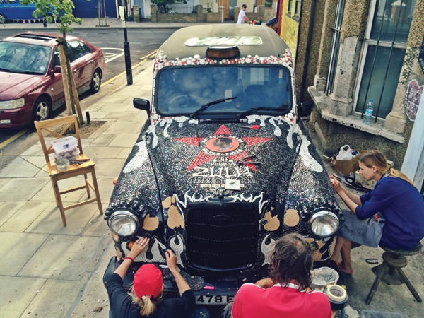

SIN-YING HO, Collision Course, 2006
In Collision Course, SIN-YING HO shows the impact of globalisation on culture. Being born in Hong Kong, emigrated to Canada and then settled down in the United States, she witnessed how political colonialism and economic globalization has imposed using a foreign language in order to communicate. This then subsequently lead to the collision of cultures, tension, confusion and complexity in globalised communication. In this project, she makes a classical Chinese pot form and transforms them into a new form by cutting and reattaching the pieces. Computer decal transfers of contemporary international commercial logos as well as traditional Chinese symbols and some hand painted images for decoration were used to represent the cultural melding as well.

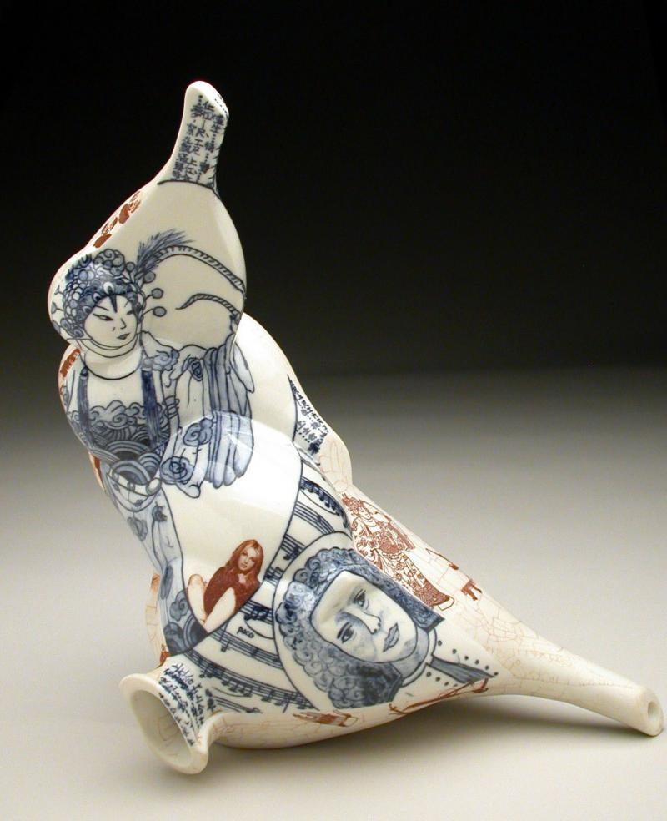

Julie Green, The Last Supper, 1999-ongoing
The Last Supper is an installation of 500 china plates with illustrations of the last meal which inmates requested before being executed in the United States since 1990. Julie Green with her artwork hopes to generate the discussion over this issue in the US among public and officials, so it will be abolished soon. She has also stated that even though the number of executions has declined in the recent years, the numbers of her plates are still growing, and she will continue the project until the death penalty is terminated nationwide.
